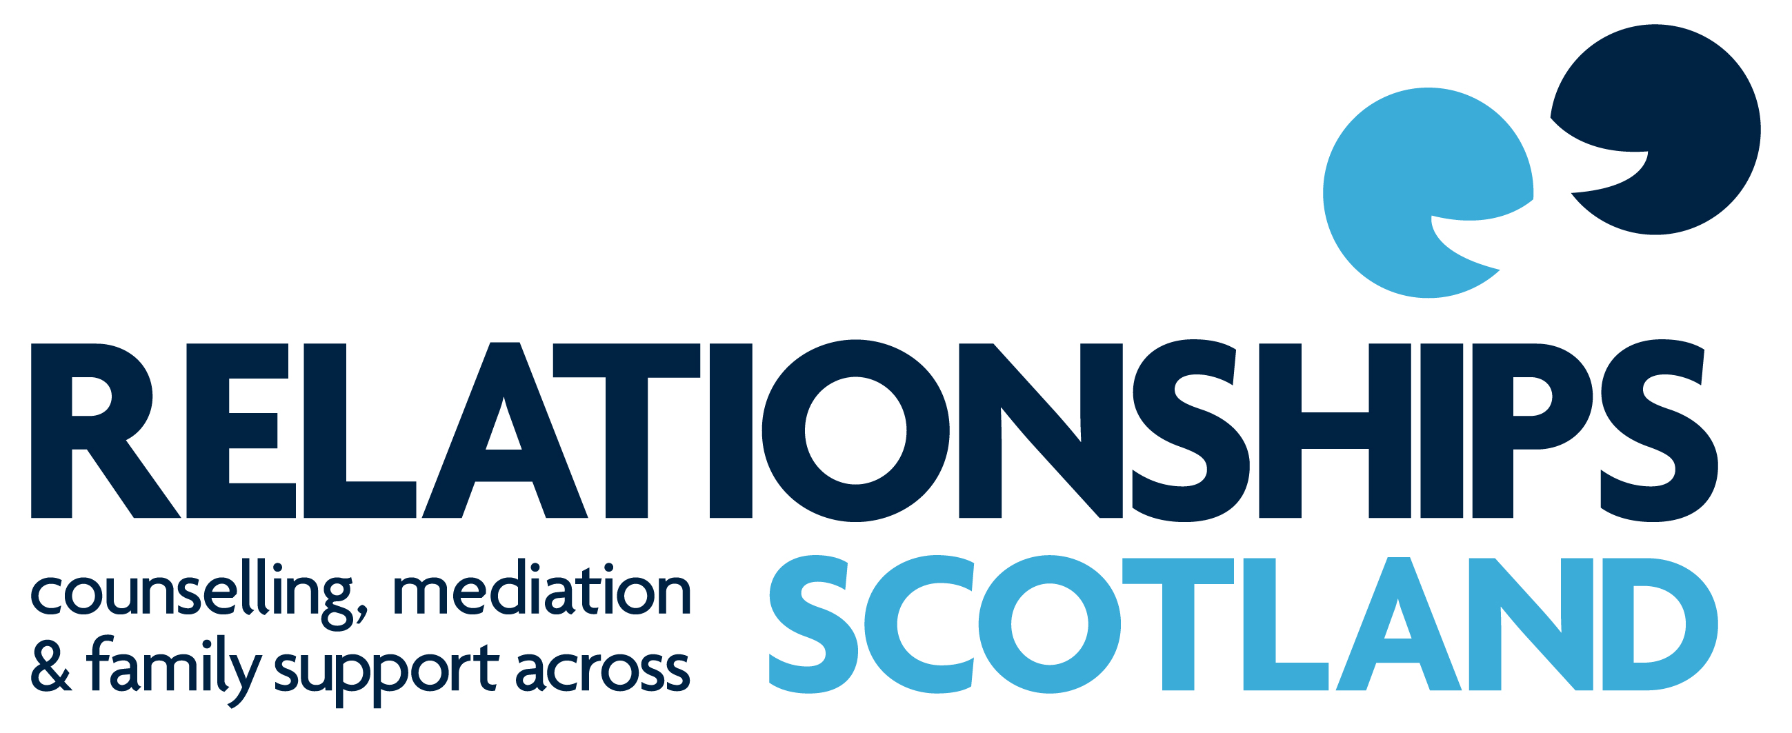

Continuing Professional Development Programme
May 2018 /July 2019

For Counsellors, Family Mediators,
Sex Therapists and Supervisors



Welcome to the 2018/19 Continuing Professional Development programme from Relationships Scotland. It is hoped that practitioners will find events here which will engage and interest them and help in the development of their practice.
All events take place at Relationships Scotland, 18 York Place, Edinburgh EH1 3EP, unless otherwise indicated.
The cost of a CPD event for members of the Relationships Scotland network is £75. The cost for external applicants remains at £115.
Specific fliers for each day, with booking forms, will be sent out about seven weeks before each event.
OVERVIEW OF CPD PROGRAMME – May 2018/July 2019
Tuesday 15th May 2018 | Introduction to Parenting Apart | Rosanne Cubitt  Sonia Bruce | Counsellors
Wednesday 30th May 2018 | Relational Reflexivity - resources, restraints, problems and possibilities | John Burnham | Mediators, Family Counsellors/Therapists
Saturday 9th June 2018 | Self-Care, Resilience and Vicarious Trauma | Sally Openshaw | SRT/Counsellors
Saturday 15th Sept 2018 | Working with risk and Suicidal Ideation | Kirsten Amis | Mediators and Counsellors
Friday 28th Sept 2018 | Counselling supervisors’ Forum | Mhairi Canning | Counselling Supervisors
Saturday 29th Sept 2018 | Reflexive Supervision | Robert Moore | Counselling Supervisors
Thursday 11th October 2018 | Mediation Supervisors’ Forum | Mhairi Canning | Mediation Supervisors
Saturday  3rd Nov 2018 | Conversational Intelligence | Martha Simpson | Mediators and Counsellors
Friday 1st March 2019 | Reflective Parenting: Bringing a mentalizing stance to parenting | Sheila Redfern | Mediators, C&YP counsellors, Family Counsellors/Therapists
Saturday 2nd March 2019 | Mentalization based work with Individuals and families | Sheila Redfern | Relationship/Individual/ Family Counsellors/Therapists
Saturday  11th May 2019 | Using and object relations focus in sexual and relationship therapy | Jane Seymour | SRT/Counsellors
Friday 7th June 2019 | Developing a Compassionate mind in mediation work | Charlie Herriot Maitland | Mediators
Saturday  8th June 2019 | Developing a Compassionate mind in relationship counselling work | Charlie Herriot Maitland | Counsellors

More information about each of these events is given on the following pages.
INTRODUCTION TO PARENTING APART
Parenting Apart information / education sessions are for parents who are going through the process of separation or divorce or are parenting while living apart. They help parents to understand about the process of separation and divorce, what their children need from them when they are living apart and how to communicate more effectively to put their children’s needs first. This training event has been designed particularly for counsellors as an opportunity for them to develop their understanding about Parenting Apart, to explore some of the tools and resources available for parents and to consider how the sessions can be integrated into practice. The event will incorporate direct input, small and large group discussion and practical exercises.

Date:  Tuesday 15th May 2018  10am- 1pm | Seminar Leader (s)  Rosanne Cubitt  Sonia Bruce
For:  Counsellors | Cost:  Members: No Cost

Rosanne Cubitt and Sonia Bruce have led the development of Parenting Apart at Relationships Scotland National Office since funding was awarded by the Scottish Government in 2015. Parenting Apart is offered by 11 Relationships Scotland Member Services and one of the aims of 2018 is to integrate this service provision within the wider range of services provided by the network. Rosanne is Head of Practice for Mediation at Relationships Scotland and Sonia is the Course Director – Mediation.

RELATIONAL REFLEXIVITY – Resources, Restraints, Problems and Possibilities
Contemporary approaches have brought a ‘breath of fresh air’ into the systemic field through creating forward looking practices, de-emphasizing problems and restraints, whilst emphasizing resources and solutions. I readily embraced this orientation yet, in my own work, not all clients/supervisees responded enthusiastically/easily to these ways of working. Based on these practice experiences I looked to create a practice map which helped me, and the people I worked with to, navigate ways through these different ways of working in therapy, training and supervision. Using feedback from clients and trainees, this map evolved into its present form:

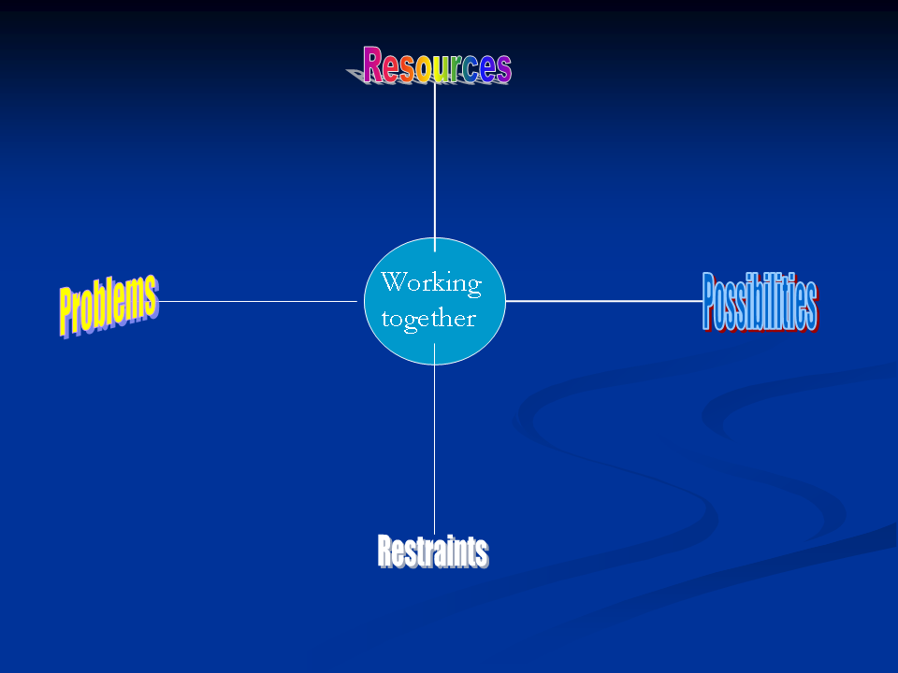

Using self and relational abilities (Burnham 1993 and 2005) the PPRRactice map can be used to create a workable fit between client and therapist, or therapist and supervisor. In this way it becomes possible to plot a unique pathway from ‘problem to possibility’ for each client/supervisee when they are seeking to ‘wrestle with what restrains them’ and ‘embrace the resources that can sustain them’ along this pathway.

This is an evolving model and the workshop will explore this process through talk, tape and exercises. Maps and sample questions will be provided to allow participants to create their own unique working profile.

Date:  Wednesday 30th May 2018 | Seminar Leader (s)  John Burnham
For:  Mediators, Family Counsellors /Therapists | Cost:  Members: £75/Non-Members: £115

John Burnham is a systemic psychotherapist working in the independent and public sectors. His practice includes therapy, supervision, training, consultation and writing.
His main clinical work is with children, young people and families at Parkview Clinic in Birmingham where he is employed as a Consultant Systemic Family Psychotherapist. He is the Director of the Systemic Training Programme. John has over 40 years of experience working with families, couples and individuals. He is formerly Director of Training at Kensington Consultation Centre (KCC) in London.

As well as training in the UK he teaches in a variety of contexts in Scandinavia, Netherlands, Greece, Singapore, the USA, and South America.

He has published numerous articles on the systemic approach to therapy, consultation, training and supervision. He is sole author of the classic text ‘Family Therapy: First steps towards a systemic approach’, published by Routledge, and is editor of the Special Edition of Human Systems known as ‘Voices from the Training Context’. His model ‘Approach, Method and Technique is widely used in a variety of training contexts.

SELF-CARE, RESILIENCE AND VICARIOUS TRAUMA
The plan for this event is to ask us each to review our own practice of self-care. Also to consider the rewards that can inflate us as therapists, followed by the hazards that can dent our resilience. Through discussion and self-reflection participants will be encouraged to assess how they keep their personal selves in good shape for practice. Research evidence on helpful strategies to develop care of ourselves, both personally and professional, will be considered.

Date:  Saturday 9th June 2018 | Seminar Leader (s)  Sally Openshaw
For:  SRT/ Counsellors | Cost:  Members: £75/Non-Members: £115
Sally Openshaw is a qualified Integrative Psychotherapist, Counsellor and Supervisor. She completed an MSc in Human Sexuality in 1991 which led to her chairing The College of Sexual and Relationship Therapy (COSRT). She is a trained EMDR Therapist and recently completed training in Sexual Addiction. She runs a training centre in North Devon.
WORKING WITH RISK AND SUICIDAL IDEATION
The day begins with exploring the personal and professional experiences of suicide within the room before focusing on the assessment of risk and suicide in relation to our clients and our self. This will be achieved by highlighting possible dilemmas and the potential impact that these may have on our practice. This process will include discussion around the organisation's relevant policies and procedures. After lunch we will use recorded case studies to consider the impact of suicide and risk on our relationship and contracting with clients before we update our own practice with regard to language, law, ethics and confidentiality. We end the day reflecting on how our own risk assessment process could be developed to build confidence in this area.

Date:  Saturday 15th Sept 2018 | Seminar Leader (s)  Kirsten Amis
For:  Mediators and Counsellors | Cost:  Members: £75/Non-Members: £115

Kirsten has been a lecturer in counselling since 1996 and has over 20 years of counselling experience in NHS, voluntary and private practice environments. She has just written and is currently piloting the new route to BACP registration. Kirsten has authored three books including Becoming a Counsellor: A Student Companion (Sage) and Boundaries, Power and Ethical Dilemmas in Counselling and Psychotherapy (Sage) as well as the MindEd session Working With Severe Psychological Distress In Young Adults And Young People. Her current doctoral research is entitled Supporting the Mental Wellbeing of students in Scottish Colleges. Kirsten was initially a psychiatric nurse and is currently a member of BACP's UC College SIG.

COUNSELLING SUPERVISORS’ FORUM
This is an opportunity for counselling supervisors to meet to discuss organisational and practice issues that have implications for Counselling Practice
Date:  Friday 28th Sept 2018 | Seminar Leader (s)  Mhairi Canning
For:  Counselling Supervisors | Cost:  No cost.

Mhairi Canning is the CPD and Supervision manager at Relationships Scotland. She has been a couple counsellor since 1997 and a Supervisor since 2004. Mhairi oversees the National CPD programme and the support for supervision in the network.

REFLEXIVE SUPERVISION
On this CPD workshop participants will have an opportunity to form a learning community for the day and co-create a rich experience of learning. As experienced and new supervisors, we will be invited to review our personal philosophy of the relationship we use the word supervision to describe. Through immersion in experience we can collectively make the 'reflexive turn’ in order to enrich the experience of supervision while enhancing our capacity to develop our own cognitive and emotional intelligence at the service of supervisee learning.

Date:  Saturday 29th Sept 2018 | Seminar Leader (s)  Robert Moore
For:  Counselling Supervisors | Cost:  Members: £75/Non-Members: £115
Robert Moore is a self-employed psychoanalytic psychotherapist (ICP) and group psychotherapist (AGPA) based in Belfast, Bobby is self-employed as a psychotherapist, supervisor, executive coach, mediator and facilitator. As Director of the Centre for Re-Sourceful Leadership he works internationally (India, Africa, USA, Europe) supporting sustainable leadership through individual and team supervision, leadership coaching and leadership workshops. Based on his book, Reflexive Supervision, Bobby designed the Diploma in Reflexive Supervision, which is delivered by a team of practitioners from a wide range of professional backgrounds. He also works as a trainer and supervisor for social work, education, nursing, psychology and multi-disciplinary teams in the NHS.

MEDIATION SUPERVISORS’ FORUM
This is an opportunity for mediation supervisors to meet to discuss organisational and practice issues that have implications for Mediation Practice
Date:  Thursday 11th October 2018 | Seminar Leader (s)  Mhairi Canning
For:  Mediation Supervisors | Cost:  No cost.

Mhairi Canning is the CPD and Supervision manager at Relationships Scotland. She has been a couple counsellor since 1997 and a Supervisor since 2004. Mhairi oversees the National CPD programme and the support for supervision in the network.

CONVERSATIONAL INTELLIGENCE®
Conversational Intelligence® (C-IQ) embraces the new learning and research about neurochemistry with the basic building block of conversation. Whilst founded on evidence based research and scientific learning, it is entirely practical, pragmatic and powerful. Improving your C-IQ is as important as improving your EQ (Emotional Intelligence).
Every relationship, whether business or personal, is built using the foundational building block of a conversation. A research project at Stanford University suggests that 9 out of 10 conversations miss the mark!!
“Everything happens through conversations.” Judith E. Glaser

If you would like to complete a C-IQ Catalyst Survey and Report and have a feedback session on your conversational style and dynamics before the day, we are giving this at a reduced cost of £100 when booked with attendance on the day. This is a reduction of £75 on our normal price. Please note: THIS IS ENTIRELY OPTIONAL AS THE DAY IS STAND ALONE.

Date:  Saturday 3rd November 2018 | Seminar Leader (s)  Martha Simpson
For:  Mediators and Counsellors | Cost:  Members: £75/Non-Members: £115

Martha Simpson MSc, BSc, MAC. Following more than 20 years in senior roles (two of them national) in family support, pre-school Education, and Mental Health, Martha set up her own business in 2007 bringing her wealth of experience to clients and client organisations. Her Master’s Degree researched the impact of coaching on Women in Senior Roles; she is a qualified and highly respected Executive Coach; Leadership Development Consultant; Employment and Workplace Mediator and one of the first people certified globally as a Conversational Intelligence® Coach/Consultant.

REFLECTIVE PARENTING: BRINGING A MENTALIZING STANCE TO PARENTING
This is Dr Sheila Redfern’s own model of an adapted mentalization based approach to parenting. Dr Redfern will translate the research findings and concepts relating to emotional understanding and behaviour management into ordinary language and practical parenting. Professionals will be able to use these in their work with parents, children and families via a toolkit of practical and applicable devices for both regulating emotions in the self (self- mentalizing for

adults and parents) and teaching parents how to mentalize their child or their partner. This will be discussed and practised in different scenarios designed to bring about a new stance of interacting with the parents you are working with. It is a method of imparting this knowledge to these parents to bring to their interactions with their children, in a way that will help them better manage their emotions and behaviour, and ultimately help parents and children to feel closer to one another. This approach will be discussed with particular reference to those working in mediation and with families where there are relatively high levels of conflict.

Date:  Friday 1st March 2019 | Seminar Leader (s)  Sheila Redfern
For:  Mediators, C&YP’s Counsellors,Family Counsellors/ Therapists | Cost:  Members: £75/Non-Members: £115
Dr Sheila Redfern is Director at Redfern Psychology and Head of Specialist Clinical Services for Trauma and Maltreatment at Anna Freud National Centre for Children and Families. Sheila works clinically with looked after children, foster carers and adoptive parents and parents and adolescents, mostly using mentalization based treatments. Sheila co-created the Reflective Parenting model and the Reflective Fostering Programme, an adaptation of this for foster carers. Sheila is an accredited MBT-A supervisor and accredited MBT (for adults) practitioner and also accredited Video Interaction Guidance (VIG) practitioner. Prior to working at Anna Freud, Sheila worked for 20 years as an NHS consultant clinical psychologist in CAMHS teams across London.
Sheila is author of Reflective Parenting: A Guide To Understanding What’s Going on in Your Child’s Mind (Routledge).

MENTALIZATION BASED WORK WITH INDIVIDUALS AND FAMILIES
Dr Sheila Redfern will guide practitioners through the core principles of the theory of mentalization, looking at the core concepts and also the core techniques associated with this approach. The seminar will give practitioners a basic introduction to the theory and to its origins and links to attachment theory, and then look at the practical application of this theory to those working with individuals and families. The capacity to mentalize refers to the ability to be able to reflect on the thoughts and feelings of another person as well as one’s own mind. It is often difficult to separate out the two and when arousal levels are either too high or too low, we fail to mentalize well. It is in these lapses of mentalizing that misunderstandings and conflicts arise, and therefore this seminar will focus on how to spot moments where this capacity goes ‘off line’ and what causes this, and also noticing good mentalizing and the factors that help to promote it in relationships.
Date:  Saturday 2nd March 2019 | Seminar Leader (s)  Sheila Redfern
For:  Relationship Counsellors, Family Counsellors/Therapists | Cost:  Members: £75/Non-Members: £115
Dr Sheila Redfern is Director at Redfern Psychology and Head of Specialist Clinical Services for Trauma and Maltreatment at Anna Freud National Centre for Children and Families. Sheila works clinically with looked after children, foster carers and adoptive parents and parents and adolescents, mostly using mentalization based treatments. Sheila co-created the Reflective Parenting model and the Reflective Fostering Programme, an adaptation of this for foster carers. Sheila is an accredited MBT-A supervisor and accredited MBT (for adults) practitioner and also accredited Video Interaction Guidance (VIG) practitioner. Prior to working at Anna Freud, Sheila worked for 20 years as an NHS consultant clinical psychologist in CAMHS teams across London.
Sheila is author of Reflective Parenting: A Guide To Understanding What’s Going on in Your Child’s Mind (Routledge).
USING AN OBJECT RELATIONS FOCUS IN SEXUAL AND RELATIONSHIP THERAPY
Object Relations Theory suggests that we are all driven to form relationships from the moment we are born. The first of these is with the primary caregiver, usually the mother, later followed by other family members. The importance of this first ‘couple relationship’ lies in the profound affect it can have on subsequent relationships through the mechanisms of projection, transference and countertransference. This way of thinking about an adult couple can access deeper, less conscious, levels of their relationship. It can also unlock a stuck situation in therapy and enable new insight for the couple and their therapist. Where only one partner attends therapy an object relations approach enables the therapist to consider the ‘absent other’ and think with the client about the impact of therapy on the relationship as a whole rather than considering the presenting partner in isolation.
This day is for therapists and students from a variety of modalities who see couples and individuals with relationship and sexual difficulties who do not respond to a straightforward CBT treatment. This day explores the development of Object Relations Theory and considers the way it can deepen our understanding of the clients we see.

Date:  Saturday 11th May 2019 | Seminar Leader (s)  Jane Seymour
For:  SRT/Counsellors | Cost:  Members: £75/Non-Members: £115

Jane Seymour has been a relationship counsellor and psychosexual therapist for the past 25 years. ​She spent two years as a Childline counsellor prior to training ​as a psychodynamic couple counsellor and psychosexual therapist at London Marriage Guidance where she became a staff member. She then went on to complete an MA in Psychoanalytic Studies at Goldsmiths College and joined Tavistock Relationships where she devised and ran the MSc in Psychosexual and Relationship Therapy for several years. ​ Jane currently teaches on the Introductory Courses at TR as well as

supervising on the MA. She is in private practice ​and has delivered training for various other ​organisations including Relate, BUPA, The Metropolitan Police and The Royal Shakespeare Company.
​
DEVELOPING A COMPASSIONATE MIND IN MEDIATION WORK
The emerging science and practice of Compassion-Focused Therapy (CFT; Gilbert, 2009; 2010), with its roots in evolutionary psychology, attachment theory, and neuroscience, may offer a useful framework for approaching some of the challenges of mediation work, at each of the personal, professional, and organisational levels. In this 1-day workshop, we will start with an understanding of why compassion is important. The reality is that we just find ourselves here, in the flow of life, with a ‘tricky brain’ that can cause all sorts of problems for ourselves, our clients and our systems. A lot of what happens in our minds is not our fault, but it is still up to us what we want to do about it. In the workshop, we will explore how our evolved minds can be orientated in certain ways depending on our social motives, and we will also consider the research that
shows how orientating our minds towards compassion for self and others can bring a variety of positive mental and physical and health benefits. We will then learn some techniques and practices to help us cultivate compassion in our personal and professional lives. The workshop will combine exercises that may help us develop compassion for ourselves, as well as those that facilitate our clients' development of compassion within our mediation work. A combination of group discussion exercises, pair work, and experiential practice will be used.

Date:  Friday 7th June 2019 | Seminar Leader (s)  Charlie Herriot Maitland
For:  Mediators | Cost:  Members: £75/Non-Members: £115

Dr Charlie Heriot-Maitland is a clinical psychologist, researcher, and trainer working at the University of Glasgow and at Balanced Minds, Edinburgh. In his academic work, he is currently researching
the application of Compassion-Focused Therapy (CFT) approaches in both NHS mental health services and in social services. He provides psychological therapies in the NHS and in a CFT practice (Balanced Minds). He also runs compassion training workshops for practitioners and the general public.

DEVELOPING A COMPASSIONATE MIND IN RELATIONSHIP COUNSELLING WORK
Compassion Focused Therapy (CFT; Gilbert, 2009; 2010) aims to help people regulate threat-based emotions, experiences, and conflicts by building internal feelings of safeness and affiliation, and by providing contexts, practices and insights that facilitate the development of compassion to self and others. As such, CFT can offer a useful framework for approaching some of the challenges of couples counselling work, at each of the personal, professional, and organisational levels.

In this one-day workshop, we will explore how our evolved minds can be orientated in certain ways depending on our social motives, and we will also consider the research that shows how orientating our minds towards compassion for self and others can bring a variety of positive mental and physical and health benefits. We will then learn some techniques and practices to help us cultivate compassion in our personal and professional lives. The workshop will combine exercises that may help us develop compassion for ourselves, as well as those that facilitate our clients' development of compassion within our counselling work. A combination of group discussion exercises, pair work, and experiential practice will be used.

Date:  Saturday 8th June 2019 | Seminar Leader (s)  Charlie Herriot Maitland
For:  Counsellors | Cost:  Members: £75/Non-Members: £115

Dr Charlie Heriot-Maitland is a clinical psychologist, researcher, and trainer working at the University of Glasgow and at Balanced Minds, Edinburgh. In his academic work, he is currently researching the application of Compassion-Focused Therapy (CFT) approaches in both NHS mental health services and in social services. He provides psychological therapies in the NHS and in a CFT practice (Balanced Minds). He also runs compassion training workshops for practitioners and the general public.

Individual fliers with more information and a booking form will be available before each event. Please contact Diana Reilly or Liz Thackwray for more details.

diana.reilly@relationships-scotland.org.uk or liz.thackwray@relationships-scotland.org.uk

Unless otherwise indicated, all events will take place at Relationships Scotland,
18 York Place, Edinburgh EH1 3EP

Booking:
Practitioners who are self-funding can book a place by
- Using the booking form attached to the flier

- Those who are requesting their member service to fund their place must ask the service to make the booking on their behalf.
Note: It is important to make a formal booking even if you have already expressed interest in attending the day.

*Access: there are five steps at the front and ten at the rear of York Place. The training room is on the first floor. We have a small lift which runs from the ground floor to the third floor and cannot be used in the event of fire. If you experience any difficulty with mobility, or if there is anything else that could inhibit your participation in this training, it is important that you let us know, to ensure your safety at the event. We have a hearing induction loop available. Please let us know if you would like to make use of this facility.

Cancellation policy:
Invoices will be issued shortly after the closing date.
Cancellation 11 days or more before the date of the event: 100% refund
Cancellation between 10 days and 4 days before the date of the event: 50% refund
Cancellation 3 days or less before the date of the event: no refund, but services can send a replacement.
If a course or event is cancelled by Relationships Scotland (because of insufficient numbers or unforeseen circumstances) then all fees will be fully refunded. Unfortunately, we are unable to reimburse out of pocket expenses, such as travel and accommodation.
In exceptional circumstances, Member Services or individuals may request a refund of the cost of CPD event or a free place at a future event. Examples of exceptional circumstances include, for example, the admission to hospital at short notice or a family bereavement.

Requests for refunds and/or free places at future events will be considered by the Office Bearers Group (Chair, Vice-Chair and Treasurer of the National Office).
All requests for refunds and/or free places at future events should be made in writing or by e-mail to the CPD and Supervision Manager.

