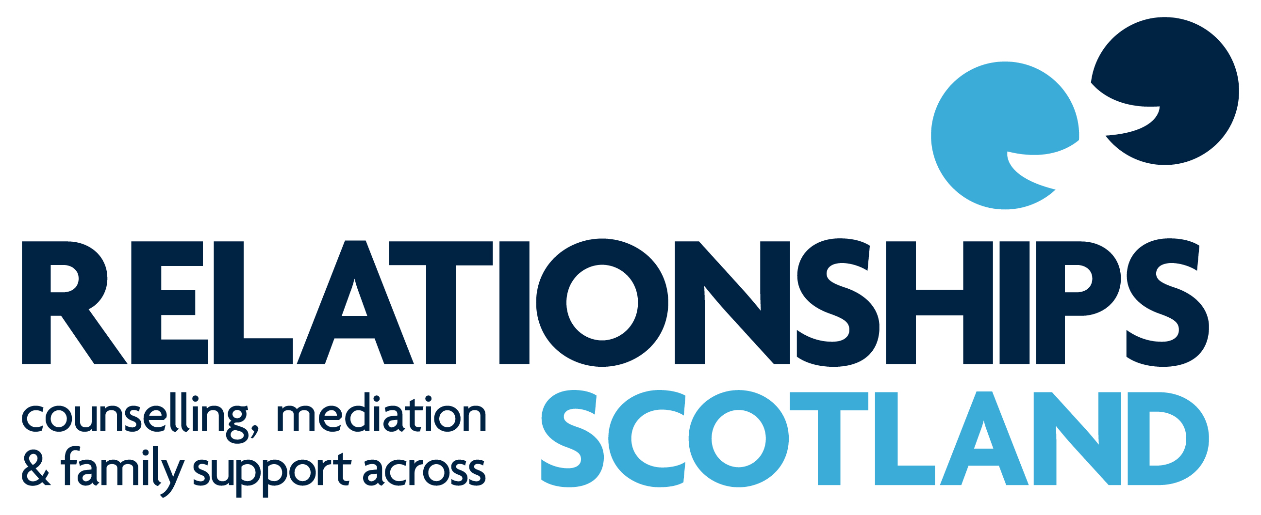

Continuing Professional Development Programme
October 2017/September 2018

For Counsellors, Family Mediators,
Sex Therapists and Supervisors



Welcome to the 2017/18 Continuing Professional Development programme from Relationships Scotland. It is hoped that practitioners will find events here which will engage and interest them and help in the development of their practice.
All events take place at Relationships Scotland, 18 York Place, Edinburgh EH1 3EP, unless otherwise indicated.
The cost of a CPD event for members of the Relationships Scotland network is £75. The cost for external applicants remains at £115.
Specific fliers for each day, with booking forms, will be sent out about seven weeks before each event.
OVERVIEW OF CPD PROGRAMME - October 2017/September 2018
Thursday 5th October | Enhancing our Experience of Supervision  Supervision Forum | Kevin Chandler  Mhairi Canning | Mediation Supervisors
Friday 6th October | Counselling Supervisors’ Forum | Mhairi Canning | Counselling Supervisors
Saturday 7th October | Intimacy and Change | Kevin Chandler | Counselling Supervisors
Thursday 26th October | Children and Young People’s Mental Health: Positive Wellbeing | Alison Ebbitt | C&YP’s Counsellors,  Mediators,  Contact Centre Workers
Friday 10th November | Introduction to Transactional Analysis for Mediators | Robin Walford | Mediators
Saturday 11th November | Transactional Analysis with Couples – Part 2 | Robin Walford | Counsellors
Saturday 17th March | The Eternal Triangle | Susan Quillam | Counsellors
Wednesday 21st March | Working directly with Children and Young People – Consent, Rights and Opportunities | Briony Cruden  Rosanne Cubitt | C & YP’s Counsellors,  DCCM Mediators,  Managers/practice managers of C&YP direct services
Friday 20th April | Innovative models for working with Domestic Abuse | Anna Mitchell Catriona Grant | Mediators and Counsellors
Wednesday 30th May | Relational Reflexivity - resources, restraints, problems and possibilities | John Burnham | Mediators
Saturday 9th June | Self-Care, Resilience and Vicarious Trauma | Sally Openshaw | SRT/Counsellors
Saturday 15th Sept | Conversational Intelligence | Martha Simpson | Mediators and Counsellors

More information about each of these events is given on the following pages.

Mediation Supervisors’ CPD Event/Forum – Edinburgh
Enhancing Our Experience of Supervision
Kevin has delivered very well received CPD events for Counselling Supervisors for the past two years. We are delighted to have him offer this day for Mediators.
This CPD event will form part of the Mediation Supervisors’ Forum
and be followed at 3pm with an hour on the normal business of the Forum
The Aim of this CPD event is to provide supervisors with an in-depth opportunity to explore their experience of Mediation Supervision from both sides of the supervisory relationship; and to learn more about what works, and what hinders and frustrates, in supervisory relationships.
Please come prepared not simply to listen to the presenter, but to take part; for the event will rely significantly on your active engagement in various structured exercises to highlight key aspects of the supervisory relationship, and small group-work to facilitate the sharing of supervisors’ knowledge and experience.
In designing this event I have drawn not only on my experience of supervising in various professional settings but also held in mind a key principle: that work such as mediation involves the worker at both the personal and the professional levels; the two aspects of self, each affecting, and being affected by, the other. It therefore follows that in our supervision we should focus on both the personal and the professional domains, and be alive to the impact of each upon the other.
And so, I hope participants will respond to the material of this CPD event at both the personal and the professional levels. This event invites us to think anew about this activity we call supervision, and my approach is pragmatic, starting not from some abstract theoretical angle, but from our own experience; of how supervision works well, and how it sometimes falters, flounders and fails.
My hope is that you will find the event a stimulation and nourishing experience.
Date:  Thursday 5th October(Edinburgh) | Seminar Leader (s)  Kevin Chandler/Mhairi Canning
For:  Mediation Supervisors | Cost:  £50

Kevin Chandler is a BACP Senior Accredited Counsellor/Psychotherapist & Supervisor.
He has been a supervisor and trainer of counsellors since 1982 and has worked in Relate, in Higher Education, and in Private Practice.
He is the author of LISTENING IN: A Novel of Therapy & Real Life (pub: Accent Press)
& Fifty-Minute Hour (a novelette, in the Legend Press collection ‘8 hours’)
and for 2 years penned the ‘In Practice’ column in the BACP Journal, Therapy Today

Mhairi Canning is the CPD and Supervision manager at Relationships Scotland. She has been a couple counsellor since 1997 and a Supervisor since 2004. Mhairi oversees the National CPD programme and the support for supervision in the network.
Counselling Supervisors’ Forum – Edinburgh
This is an opportunity for counselling supervisors to meet to discuss organisational and practice issues that have implications for counselling practice.
Date:  Friday 6th October (Edinburgh) | Seminar Leader (s)  Mhairi Canning
For:  Counselling Supervisors | Cost:  No cost

Mhairi Canning is the CPD and Supervision manager at Relationships Scotland. She has been a couple counsellor since 1997 and a Supervisor since 2004. Mhairi oversees the National CPD programme and the support for supervision in the network.

Intimacy and Change
Back by popular demand! The content and delivery of the past two events with Kevin Chandler has moved us to ask him to return for another year! This will be a day of 2 halves:
INTIMACY:The two great relational themes of Couple Relationships are INTIMACY & ATTACHMENT and the difficulties clients bring to couple counselling usually arise from one or other
(& occasionally both!) of these themes. Broadly speaking, attachment is to do with security & belonging; whereas intimacy is to do with being truly recognised & known at a deep personal level.
Over the years, I have found that many couple counsellors (along with many of their clients) have a somewhat limited understanding of the variable nature of INTIMACY, equating it often with a generalised notion of closeness, or using it as a coy pseudonym for sexual relating. I think this is to ‘miss a trick’. If we supervisors can enlarge and sharpen our supervisees’ understanding of the concept and experience of intimacy by exploring its various currencies, the theme of transitions into and out of intimacy, and the fears associated with too much intimacy, we can do much to extend and deepen our supervisees’ work with their clients. The morning’s work will attempt to do just that, using theoretical concepts, experiential exercises and a movie extract to really illuminate the subject.
CHANGE: All clients come to counselling because of CHANGE.
If intimacy and attachment are the two great themes of Couple Relationships, then CHANGE is the
hinge between the two, and its creaking, seizing up, and even its breaking is what brings couples to counselling. Either an unwanted change has already occurred which they would reverse if only they could, or they wish to bring about a change which stubbornly eludes all their best efforts.
The afternoon’s work will consider various types of change that clients are seeking,
the different locations of such changes; and how the types and locations of change interlink.
We shall also consider the dynamic of change: within couple relationships, within client-

counsellor relationships, and within the supervisor-supervisee relationship, in terms of both motivation and resistance. Again, the event will include not only theoretical frameworks and concepts backed up with clear and detailed summary sheets, but also employ active and experiential exercises,
as well as opportunities for sharing in small groups.

Date:  Saturday 7th October | Seminar Leader (s)  Kevin Chandler
For:  Counselling Supervisors | Cost:  Members: £75/Non-Members: £115

Kevin Chandler is a BACP Senior Accredited Counsellor/Psychotherapist & Supervisor.
He has been a supervisor and trainer of counsellors since 1982 and has worked in Relate, in Higher Education, and in Private Practice. He is the author of LISTENING IN: A Novel of Therapy & Real Life (pub: Accent Press) & Fifty-Minute Hour (a novelette, in the Legend Press collection ‘8 hours’)
and for 2 years penned the ‘In Practice’ column in the BACP Journal, Therapy Today.

Children and Young People’s Mental Health: Positive Wellbeing
This day will help raise awareness of signs and symptoms of mental health issues when working with children and young people in a contact centre/counselling situation and develop an understanding of how to respond appropriately to these.
We will look at what constitutes positive mental health in children and young people and how we can assist those who need help. We will explore ways in which we can develop our own confidence in what to say and do when faced with a young person who is in crisis. Looking after our own mental health in difficult situations will also be discussed.

Date:  Thursday 26th October | Seminar Leader (s)  Alison Ebbitt
For:  Mediators, Children & Young People’s Counsellors, Contact Centre Workers | Cost:  Members: £75/Non-Members: £115

Alison Ebbitt is a qualified mental health social worker, Counsellor and Mediator. She practices family and inter-generational Mediation. She is also trained in financial mediation (AIM) and Direct Consultation with Children in Mediation. She is a tutor on Relationships Scotland’s Certificate in Family Mediation and on the law diploma at Strathclyde and Edinburgh University and also on a master’s course in Strathclyde University. She delivers training in mental health adult children and young people, child protection and self-harm

Transactional Analysis for Mediators
This day will help Mediators gain an understanding of key transactional analysis concepts, such as Ego States Theory, Discounting and Passivity, Racket Feelings and Psychological Games and how to apply this thinking to the mediation process.
The day will incorporate direct teaching, small and large group discussion and practical exercises

Date:  Friday 10th November | Seminar Leader (s)  Robin Walford
For:  Mediators | Cost:  Members: £75/Non-Members: £115

Robin Walford is a qualified Transactional Analyst. He works in private practice offering individual and couple psychotherapy. He is an external trainer to many organisations including Bradford University and Relate. He is a director of Leeds Psychotherapy Training Institute.

Transactional Analysis with Couples (Part 2)
Cycle of Reinforcement – Identifying and working with repetitive, destructive patterns of relating.
At the unconscious level individuals choose partners who ‘fit’ their early childhood experience. In this way the familiar responses are evoked and couples then replay these repetitive, outdated and primitive patterns of thinking feeling and behaviour with each other. The Cycle of reinforcement enables the counsellor to help the couple identify these patterns and adopt updated and productive problem - solving strategies.
Components of TA theory taught or revised: Early Life Decisions, Reinforcing Memories, Cycle of Reinforcement.
A model of couple development with treatment for each stage.
As with groups, couples move through predictable developmental stages. Counsellors are enabled to identify each stage and understand the couple’s developmental needs at each stage.

Date:  Saturday 11th November | Seminar Leader (s)  Robin Walford
For:  Counsellors | Cost:  Members: £75/Non-Members: £115

Robin Walford is a qualified Transactional Analyst. He works in private practice offering individual and couple psychotherapy. He is an external trainer to many organisations including Bradford University and Relate. He is a director of Leeds Psychotherapy Training Institute.

Working directly with Children and Young People – Consent, Rights and
Opportunities
This day has been designed for practitioners who work directly with children and young people in the context of family relationship issues, family conflict and communication issues, separation, divorce and contact issues. It would also be useful for Managers / Practice Managers of Services that provide or want to develop services that work directly with children and young people (e.g. children’s counselling in schools, supporting children to complete the F9 form and/or write reports to the court around contact issues, hearing children’s views directly in mediation or counselling).

The morning will be an opportunity to update our knowledge and understanding around children’s legal capacity to consent (with reference to Gillick/Fraser Guidelines) as well as children’s rights to access and participate in services, with input from the Scottish Child Law Centre.

The afternoon will be facilitated in a ‘forum’ style. There will be input from a number of practitioners and we will share learning from around our network about service provision directly for children and young people to support them in the context of family issues with a view to extending these services.

Date:  Wednesday 21st March | Seminar Leader (s)  Briony Cruden / Rosanne Cubitt
For:  C & YP’s Counsellors,  DCCM Mediators,  Managers/practice managers  of C&YP direct services | Cost:  Members: £75/Non-Members: £115

Briony Cruden is a qualified solicitor with a focus on family and child law. Briony is the newest member of the Scottish Child Law Centre and provides advice to service users on a wide range of child law issues including contact and residence, court procedure and children’s hearings. Briony is driven by the importance of children’s rights and is dedicated to helping children express their views on matters which relate to them.

Rosanne Cubitt is Head of Professional Practice for mediation at Relationships Scotland and has been a mediator since 2006. Rosanne oversees the direct consultation with children in mediation (DCCM) course and has been leading developments at the national office to take forward this work and extend the role of the child consultant.

The Eternal Triangle
What's happening when a partnership shifts to include a third person - when one partner looks outside for a sexual or emotional connection? For her book The Eternal Triangle, Susan Quilliam spoke to 50 partners from all three sides of that dynamic. Since then she has worked with many clients in her coaching practice to help them understand and resolve their situation.

In this workshop she offers the opportunity to explore such questions as: What's going on in an eternal triangle? Why do such triangles happen? How can we help clients manage the situation in the present, reconcile the past and future proof their relationship?

The workshop will be interactive and exercise-based rather than didactic, with participants encouraged to reflect on their own attitudes as well as to exchange professional insights and skills in a supportive way.

Date:  Saturday 17th March | Seminar Leader (s)  Susan Quillam
For:  Counsellors | Cost:  Members: £75/Non-Members: £115

Susan Quillam is a writer, coach, consultant, columnist and facilitator specialising in the issue of intimate relationships. Her books include two for Relate - How to Stay Together and Stop Arguing Start Talking. Her interest in what happens when partners ‘look outside' their relationship began in 1990 when she wrote her book The Eternal Triangle (Pan Macmillan). Susan is delighted to be an Ambassador for Relate Cambridge, where she has also previously delivered this workshop.

Innovative Models for working with Domestic Abuse
Domestic abuse practice in Scotland has developed significantly over recent years. It is useful for mediators and counsellors to be aware of how the field is evolving in order to best support the families they work with and to work together with other professionals who are doing the same. This session will outline recent developments in domestic abuse, child welfare and trauma informed practice.

Key principles and components of the Safe and Together model - The Safe and Together model is a field-tested model, promoting a best practice approach to helping child welfare organisations and their partners ensure good decisions are made for children impacted by domestic abuse perpetrators. The model consists of a set of assumptions, principles and critical components that when utilised in domestic abuse cases, help to improve identification, assessment, documentation, case planning and decision making. This session will look at this model, its implementation in Scotland and will ask participants to consider how its principles can be applied in the counselling and mediation field. There will also be an update on how contact options between children

and their non-resident parent are being assessed where there are allegations of domestic abuse and the use of risk assessment tools and reports to the family court.

Trauma informed practice – Adopting a trauma-informed approach to working with victims of domestic abuse means attending to their emotional as well as physical safety. It involves strengthening their psychological capacity to deal with the multiple complex issues that they face in accessing safety, recovering from the traumatic effects of domestic abuse and other abuse they may have experienced, and rebuilding their lives. It also means ensuring that services operate in an environment that is inclusive, welcoming, destigmatising, and non-re-traumatising. This session will review the development of trauma informed practice and will ask participants to consider this in relation to their counselling and mediation practice.

Date:  Friday 20th April 2018 | Seminar Leader (s)  Anna Mitchell / Catriona Grant
For:  Counsellors and Mediators | Cost:  Members: £75/Non-Members: £115

Anna Mitchell has studied and worked in the domestic abuse field for 18 years. She was a social worker in the Domestic Violence Probation Project before being seconded to the Scottish Government as a Professional Advisor to support the roll out the Caledonian System. Since 2012, Anna has been employed as Domestic Abuse Lead Officer for Edinburgh’s Public Protection Partnership with the remit to help coordinate domestic abuse services across the council, police, health and the voluntary sector.

Catriona Grant is an independent social worker and Domestic Abuse Consultant. She is a registered Social Worker with over 20 years post qualifying experience and has worked as a criminal justice social worker specialising in domestic abuse. She supported the development of the Caledonian System manuals and was seconded to Lothian & Borders Police as the Getting It Right For Every Child Co-ordinator. She has an LLB in Law with Distinction from Edinburgh Napier University, PG Certificate in Child Welfare & Protection from Stirling University and has gained the Diploma in Professional Legal Practice at Edinburgh University.

Relational Reflexivity - resources, restraints, problems and possibilities
Contemporary approaches have brought a ‘breath of fresh air’ into the systemic field through creating forward looking practices, de-emphasizing problems and restraints, whilst emphasizing resources and solutions. I readily embraced this orientation yet, in my own work, not all clients/supervisees responded enthusiastically/easily to these ways of working. Based on these practice experiences I looked to create a practice map which helped me, and the people I worked with to, navigate ways through these different ways of working in therapy, training and supervision. Using feedback from clients and trainees, this map evolved into its present form:

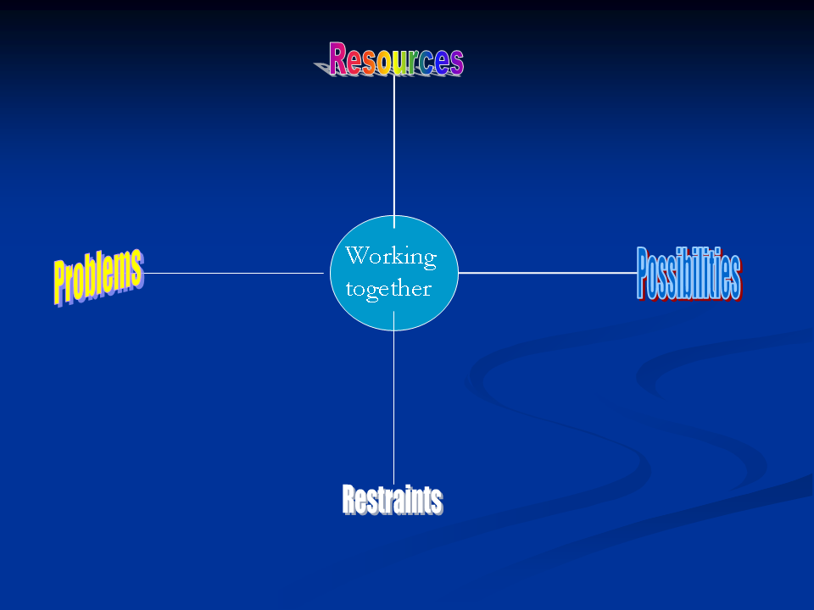

Using self and relational abilities (Burnham 1993 and 2005) the PPRRactice map can be used to create a workable fit between client and therapist, or therapist and supervisor. In this way it becomes possible to plot a unique pathway from ‘problem to possibility’ for each client/supervisee when they are seeking to ‘wrestle with what restrains them’ and ‘embrace the resources that can sustain them’ along this pathway.

This is an evolving model and the workshop will explore this process through talk, tape and exercises. Maps and sample questions will be provided to allow participants to create their own unique working profile.

Date:  Wednesday 30th May 2018 | Seminar Leader (s)  John Burnham
For:  Mediators | Cost:  Members: £75/Non-Members: £115

John Burnham is a systemic psychotherapist working in the independent and public sectors. His practice includes therapy, supervision, training, consultation and writing.
His main clinical work is with children, young people and families at Parkview Clinic in Birmingham where he is employed as a Consultant Systemic Family Psychotherapist. He is the Director of the Systemic Training Programme. John has over 40 years of experience working with families, couples and individuals. He is formerly Director of Training at Kensington Consultation Centre (KCC) in London.

As well as training in the UK he teaches in a variety of contexts in Scandinavia, Netherlands, Greece, Singapore, the USA, and South America.
He has published numerous articles on the systemic approach to therapy, consultation, training and supervision. He is sole author of the classic text ‘Family Therapy: First steps towards a systemic approach’, published by Routledge, and is editor of the Special Edition of Human Systems known as ‘Voices from the Training Context’. His model ‘Approach, Method and Technique is widely used in a variety of training contexts.

Self-care, Resilience and Vicarious Trauma
The plan for this event is to ask us each to review our own practice of self-care. Also to consider the rewards that can inflate us as therapists, followed by the hazards that can dent our resilience. Through discussion and self-reflection. Participants will be encouraged to assess how they keep their personal selves in good shape for practice. Research evidence on helpful strategies to develop care of ourselves, both personally and professional, will be considered.

Date:  Saturday 9th June 2018 | Seminar Leader (s)  Sally Openshaw
For:  SRT/ Counsellors | Cost:  Members: £75/Non-Members: £115
Sally Openshaw is a qualified Integrative Psychotherapist, Counsellor and Supervisor. She completed an MSc in Human Sexuality in 1991 which led to her chairing The College of Sexual and Relationship Therapy (COSRT). She is a trained EMDR Therapist and recently completed a training in Sexual Addiction. She runs a training centre in North Devon.
Conversational Intelligence®
Conversational Intelligence® (C-IQ) embraces the new learning and research about neurochemistry with the basic building block of conversation. Whilst founded on evidence based research and scientific learning, it is entirely practical, pragmatic and powerful. Improving your C-IQ is as important as improving your EQ (Emotional Intelligence).
Every relationship, whether business or personal, is built using the foundational building block of a conversation. A research project at Stanford University suggests that 9 out of 10 conversations miss the mark!!
“Everything happens through conversations.” Judith E. Glaser

If you would like to complete a C-IQ Catalyst Survey and Report and have a feedback session on your conversational style and dynamics before the day, we are giving this at a reduced cost of £100 when booked with attendance on the day. This is a reduction of £75 on our normal price. Please note: THIS IS ENTIRELY OPTIONAL AS THE DAY IS STAND ALONE.

Date:  Saturday 15th September 2018 | Seminar Leader (s)  Martha Simpson
For:  Mediators and Counsellors | Cost:  Members: £75/Non-Members: £115

Martha Simpson MSc, BSc, MAC
Following more than 20 years in senior roles (two of them national) in family support, pre-school Education, and Mental Health, Martha set up her own business in 2007 bringing her wealth of experience to clients and client organisations. Her Master’s Degree researched the impact of coaching on Women in Senior Roles; she is a qualified and highly respected Executive Coach; Leadership Development Consultant; Employment and Workplace Mediator and one of the first people certified globally as a Conversational Intelligence® Coach/Consultant.

Individual fliers with more information and a booking form will be available before each event. Please contact Diana Reilly or Liz Thackwray for more details.

diana.reilly@relationships-scotland.org.uk or liz.thackwray@relationships-scotland.org.uk

Unless otherwise indicated, all events will take place at Relationships Scotland,
18 York Place, Edinburgh EH1 3EP

Booking:
Practitioners who are self-funding can book a place by
- Using the booking form attached to the flier

- Those who are requesting their member service to fund their place must ask the service to make the booking on their behalf.
Note: It is important to make a formal booking even if you have already expressed interest in attending the day.

*Access: there are five steps at the front and ten at the rear of York Place. The training room is on the first floor. We have a small lift which runs from the ground floor to the third floor and cannot be used in the event of fire. If you experience any difficulty with mobility, or if there is anything else that could inhibit your participation in this training, it is important that you let us know, to ensure your safety at the event. We have a hearing induction loop available. Please let us know if you would like to make use of this facility.

Cancellation policy:
Invoices will be issued shortly after the closing date.
Cancellation 11 days or more before the date of the event: 100% refund
Cancellation between 10 days and 4 days before the date of the event: 50% refund
Cancellation 3 days or less before the date of the event: no refund, but services can send a replacement.
If a course or event is cancelled by Relationships Scotland (because of insufficient numbers or unforeseen circumstances) then all fees will be fully refunded. Unfortunately, we are unable to reimburse out of pocket expenses, such as travel and accommodation.
In exceptional circumstances, Member Services or individuals may request a refund of the cost of CPD event or a free place at a future event. Examples of exceptional circumstances include, for example, the admission to hospital at short notice or a family bereavement.

Requests for refunds and/or free places at future events will be considered by the Office Bearers Group (Chair, Vice-Chair and Treasurer of the National Office).
All requests for refunds and/or free places at future events should be made in writing or by e-mail to the CPD and Supervision Manager.

