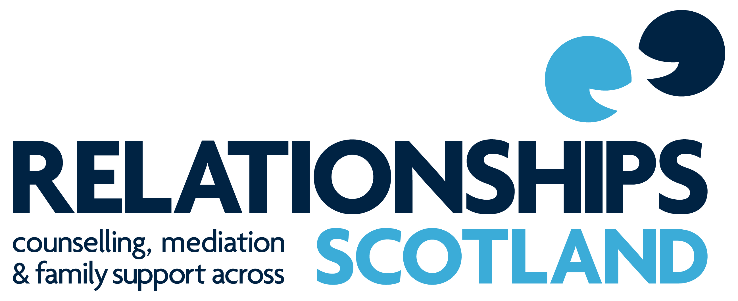

NATIONAL POLICY on

DOMESTIC ABUSE

August 2016

Relationships Scotland Statement about Abuse in Relationships

Relationships Scotland believes that behaviour that seeks to secure power and control, or instil fear for one person over another through violence, coercion, control and inequality is unacceptable. We support people to live with dignity and safety and to enjoy healthy relationships, and we respect the rights of all people, in all their diversity. We believe that people have the capacity to change their behaviour and how they relate to others. We provide a range of specialist individual, couple and family relationship support services and we take seriously our responsibility for ensuring safety for adults, children and young people.

Domestic Abuse Policy

Definition

Relationships Scotland works to the following definition of Domestic Abuse:

Domestic Abuse is behaviour that seeks to secure power and control for the abuser and to undermine the safety, security, self esteem and autonomy of the abused person. It contains elements of the use of any, or all, of physical, sexual, psychological, emotional, verbal or economic intimidation, oppression or coercion and includes disclosing or threatening to disclose intimate photographs or films. Domestic abuse can occur in any intimate partner relationship regardless of gender or sexual orientation and can be perpetrated by partners or ex-partners and be participated in or supported by extended family members.

Safety and Protection

Domestic Abuse is a risk to the safety of adults, children and young people. It is recognised that children and young people may be witness to, and may be subject to, abuse and that there is some correlation between domestic abuse and the mental, physical and sexual abuse of children.

‘Children and young people living with domestic abuse are at increased risk of significant harm, both as a result of witnessing the abuse and being abused themselves. Children can also be affected by abuse even when they are not witnessing it or being subjected to abuse themselves. Domestic abuse can profoundly disrupt a child’s environment, undermining their stability and damaging their physical, mental and emotional health. The impact of domestic abuse on a child will vary, depending on factors including the frequency, severity and length of exposure to the abuse and the ability of others in the household (particularly the non-abusive parent/carer) to provide parenting support under such adverse conditions. If the non-abusive parent/carer is not safe, it is unlikely that the children will be. Indeed, children frequently come to the attention of practitioners when the severity and length of exposure to abuse has compromised the non-abusing parent’s/carer’s ability to nurture and care for them.’

Principles

Relationship Scotland is committed to:

- Supporting individuals, couples and families affected by domestic abuse. This will involve initial discussions and decisions about the most appropriate services, and may involve signposting to other agencies.

- Protecting children, young people and vulnerable adults. This may involve making referrals to other agencies. Wherever possible clients are involved in discussions, encouraged to self-refer and supported through the reporting process.

- Working with clients to ensure appropriate safeguards are in place to support them to take control of their lives.

- Respecting diversity and working with all clients to develop safe, healthy relationships.

- Collaborating where appropriate with other agencies where clients affected by domestic abuse are experiencing complex problems.

- Enriching relationships and encouraging good and respectful communication.

Policy Statement

Relationships Scotland members recognise the impact that domestic abuse has on the abused person and their children. It is our policy to ensure that:

- Relationships Scotland members will do their utmost to keep all clients and staff safe whilst using their services. We will only offer a Service if deemed appropriate.

- Risks associated with domestic abuse will be assessed at all initial interviews. We will enable each participant to make a fully informed and voluntary decision to take part in any service with a partner or ex-partner and we will discuss and implement appropriate safety measures

- Even if domestic abuse has not emerged as an issue at initial interviews, continued attention will be paid to its possible existence during work with couples and ex-partners and if a service has to be terminated for this reason, then it will be terminated safely and alternatives explored with clients. Where suitable, external services will be discussed with clients.

- The confidentiality of a client disclosing their experience of domestic abuse will be respected. If there is cause for concern for any child, young person or vulnerable adult, or where we are legally obliged to act, we will follow the relevant procedures to ensure safety.

- Practitioners are trained to respond to power imbalances to ensure equality of participation.

http://www.scottish.parliament.uk/S4_Bills/Abusive%20Behaviour%20and%20Sexual%20Harm%20(Scotland)%20Bill/SPBill81BS042016.pdf

