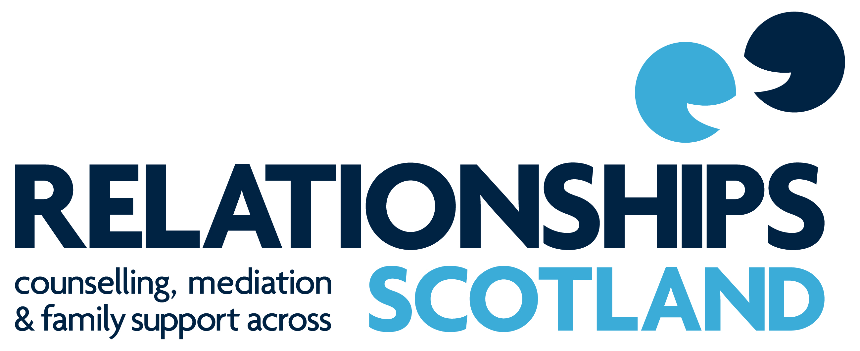

NATIONAL POLICY
on

CHILD PROTECTION

September 2017

1. CHILD PROTECTION POLICY STATEMENT

All members of Relationships Scotland shall make the safety and protection from harm of children their highest priority.

This policy is based on the following principles:
- the welfare of children is paramount
- that all children without exception have the right to protection from abuse
- that all suspicions and allegations of abuse will be taken seriously and responded to swiftly and appropriately

2. LEGAL AND POLICY FRAMEWORK

In 2014 the Scottish Government refreshed National Guidance for Child Protection. It provides guidance to all agencies working with children and their families in the statutory, voluntary and independent sectors who may have concerns about the welfare of a child and who may have to respond to information that a child is at risk of harm. It stresses the importance of collective responsibility and information sharing between agencies.

This guidance is based on GIREC; the UN Convention on the Rights of the Child; the Children’s Charter and the Framework for Standards.

In 2003 The Protection of Children (Scotland) Act allowed Scottish Ministers to set up the Disqualified from Working with Children List which came into operation on 10th January 2005. The Act aimed to improve the safeguards for children by preventing unsuitable people from working with them. Both of these documents contain guidance on procedures to be followed and these guidelines have been developed to provide a framework for Relationships Scotland Services to protect children from abuse. Local child protection guidelines should be supported by appropriate local training.

The Relationships Scotland network is fully committed to promoting children’s rights, notably their right to be protected from harm, abuse and exploitation and to be involved in any decisions that directly affect them.

Relationships Scotland members have a duty of care to implement effective policies and procedures for safeguarding the welfare of children and young people. In order to achieve this, we ensure our staff and volunteers are carefully selected, screened, trained and supervised. Furthermore we endeavour to keep up-to-date with national developments relating to the care and protection of children and young people.

Relationships Scotland also respects and upholds the Codes of Practice and Ethics that our professionals work to including where relevant - COSRT, COSCA, BACP, AFT and SMN.

Children (Scotland) Act 1995 http://www.scotland.gov.uk/Publications/2004/10/20066/44708
http://www.gov.scot/Resource/0045/00450733.pdf
http://www.scotland.gov.uk/Topics/People/Young-People/gettingitright/publications
http://www.unicef.org.uk/Documents/Publication-pdfs/crcsummary.pdf
http://www.scotland.gov.uk/Publications/2004/04/19082/34410
http://scotland.gov.uk/Publications/2004/03/19102/34603
http://www.crbs.org.uk/pocsainformation/documents/POCSA.pdf

