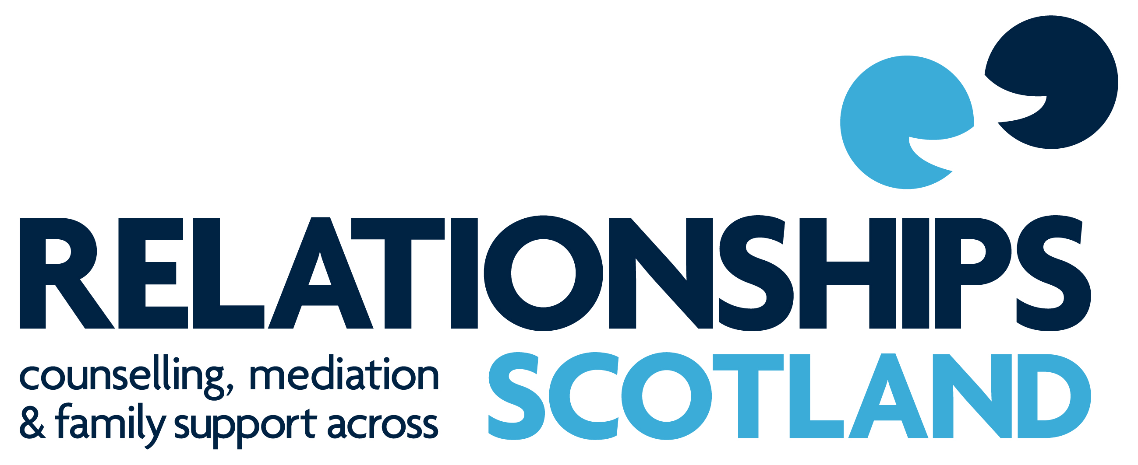

NATIONAL POLICY on

CONFIDENTIALITY and DISCLOSURE

September 2016

1. The Principles of Confidentiality

Confidentiality

Relationships Scotland member Services offer confidential counselling, mediation, Child Contact Centre and other related services to clients. They will not normally disclose any information that is given to them in confidence without prior consent from the client unless they have reason to believe that someone, especially a child or vulnerable adult, is at risk of serious harm or if required to do so by law. Any discussion between professionals within a member service or between a professional and their supervisor will not reveal the identity of clients.

Relationships Scotland members view confidentiality as an obligation and a central part of all their activities at both organisational and clinical levels. This policy details the ways in which Relationships Scotland members ensure that the appropriate level of confidentiality is afforded to all of its workers and clients.

  - Confidentiality and the Family

If a person contacts the organisation, then that fact and any other information the organisation has about them must remain confidential to that person, even if their partner, spouse or other family member joins them at a later stage unless they give their express permission for information to be passed on. No family relationship either legal or otherwise can override individual confidentiality.

1.3 Consulting Children

The case records of mediator consultations with any child will be treated as if the child is a separate client and information stored separately from their parents’ file. Permission is therefore needed from a child before records of a consultation with them are disclosed.

2 The Law, Codes of Ethics and Confidentiality

  - The Data Protection Act 1998

All information held about clients is subject to restrictions under this act. In accordance with this act Relationships Scotland members will ensure that:

- All information regarding clients will be kept appropriately secure

- All clients will be given right of access to information about themselves which is held by the service, however in doing this care will be taken not to breach the confidentiality of anyone else.

3 The Exchange of Information with Agencies or Individuals outwith the Service
Relationships Scotland Services are in general not covered by the Children & Young People Act (Scotland) 2014 as it only applies to 3rd sector organisations which are contracted or commissioned to provide a service by a statutory body. This means that unless there is a Service Level Agreement where any potential exchange of information is clearly set out and agreed, the details and particulars of a client’s involvement with a Relationships Scotland member will not be discussed with any agencies or individuals outwith the Service without the client’s consent unless they have reason to believe that someone, especially a child or vulnerable adult, is at risk of serious harm or if required to do so by law. Where two Relationships Scotland members are involved in a case (for example if a couple had intake meetings in different Services), relevant information can only be exchanged with the client’s consent.
If a child is considered to be at risk, relevant information must always be shared.
Where there is a Service Level Agreement this will stipulate that a Service must pro-actively share relevant information to the named person in relation to a child’s wellbeing.
The Service is obliged to respond to requests for information as stipulated in the Service Level Agreement. If agreement is for a particular project or area of work, then information can be requested about any client involved in this project / area of work regardless of the source of referral. You do not need to share all information but should provide information if the benefit to the child’s wellbeing is likely to be greater than any negative impact. This decision lies at the discretion of the Service Manager.
There is no statutory requirement to share information if the Service gets general funding not covered by a contract or service level agreement. However, it is good practice to consider situations where wellbeing information should be shared in the best interests of the child.
Children and their families have a right to know when information about them is being shared. Where appropriate, their consent should be sought, unless doing so would increase the risk to a child or others, or prejudice any subsequent investigation

Throughout this document, the term ‘worker’ will apply to all staff, sessional workers, volunteers and committee members

