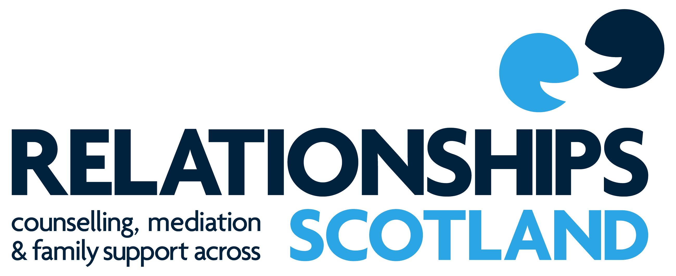
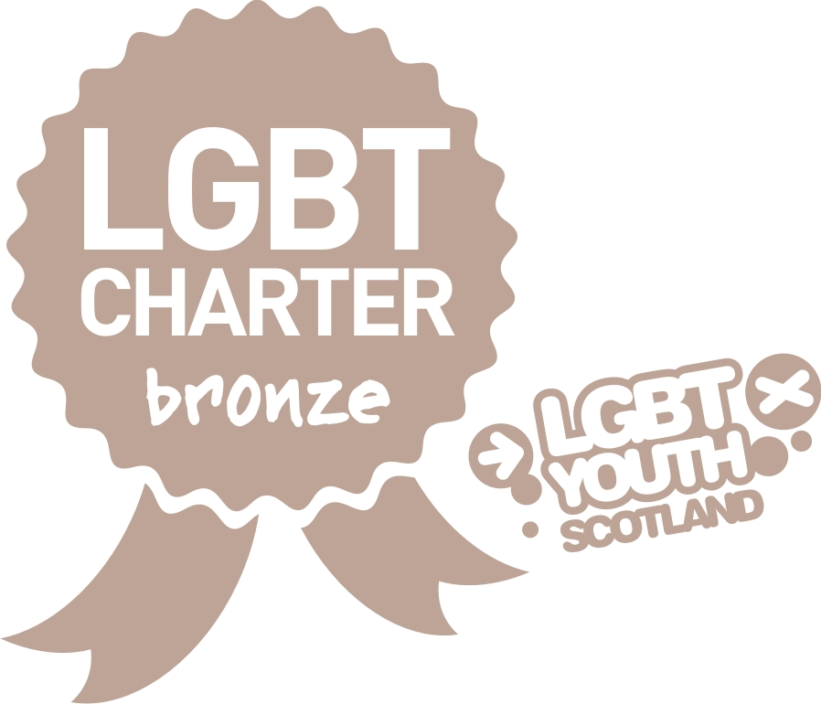

Diploma in Sex and
Relationship Therapy

Course Prospectus

August 2018 – May 2020

Contents Page
Background Information on Relationship Scotland ...................................... 2
Aims of the Course ……………………………………………………………… 3
Course Time Table/Dates ……………………………………………………… 5
Assessment Formative for Year 1 …………………………………………….. 6
Assessment Formative for Year 2 ……………………………………………... 6
Course Content for Year One …………………………………………………. 8
Course Content for Couple Work Block ……………………………………..….11
Year 2 – Sex in Context ……………………………………………………….. 12
Clinical Practice……………………………………………..…………………... .13
Application & Selection Procedure …………………………………………… 14
List of Relationship Scotland Member Services…………………………….… 15

Relationships Scotland
Relationships Scotland is the largest organisation offering relationship counselling across Scotland. Relationships Scotland supports a comprehensive national network of Relationship Counselling, Family Mediation Services and Child Contact Centers on mainland Scotland and the Scottish Islands.
The Diploma in Sex and Relationship Therapy
The Diploma in Sex and Relationship Therapy (Dip SRT) provides a professionally recognized integrative diploma, training therapists to work with individuals and couples experiencing a range of both relationship and sexual difficulties.

Why chose to train with Relationships Scotland?
- We are the largest provider of relationship counselling in Scotland.
- We have over 60 years’ experience of working with couples.
- The training is part-time on weekends and modular to maximize flexible participation.
- We offer professional training in relationship counselling delivered by experienced, accredited counsellors and trainers.
- Training includes lectures/workshops from subject specific experts as well as Relationships Scotland’s core training team.
- We have 22 member services and 15 provide counselling practice placements for students. Listed at back of this prospectus.
- The Diploma in Sex and Relationship Therapy has applied for professional validation from COSRT.
- Successful students will receive registration as a Sex and Relationship Therapist within Relationships Scotland.
- Training takes place within an attractive, stimulating environment in a spacious Georgian building in central Edinburgh.
- Students who train with Relationship Scotland are well qualified to find employment within a variety of counseling settings including the voluntary sector and the NHS.
- The course is competitively priced and fees can be paid flexibly on an agreed schedule

Diploma in Sex and Relationship Therapy
Aims of the Course:
To provide students with a comprehensive introduction to sex therapy, covering:
- Knowledge – of sexual functioning; dysfunctions and range of sexual practices
- Skills – to form therapeutic relationships and to work ethically across a range of religions, cultures, ethnicity’s, orientations, genders and relationship formats
- Practice – to feel confident and competent to deliver sex therapy programmes
- Experiential – to have space to explore attitudes, beliefs and responses to difference and diversity within sexual experiencing
- And to have an understanding of legal and ethical issues around working with sexual issues and child protection / vulnerable adults
The course will include:
- Direct taught elements by the course tutors who will be experienced either sex therapists and/ or relationship counsellors
- Input from experienced sex therapists on aspects of practice
- External speakers
- Group discussions
- Seminars and presentations
- Role play/practise sessions
- Personal development work
- Placements within a Relationships Scotland member service (if applicable)
- Supervision with an experienced and qualified sex therapy supervisor.

The three main formats of learning will be:

- Learning about:
- sexual functioning
- sexual difficulties
- sexual practices
- difference and diversity

- Learning from:
  - the group
  - the tutors
  - experienced colleagues
  - externals speakers
  - supervisors

- Learning to:
  - Assess
  - Formulate
  - Implement
  - Clinical practice

Professional Body
This course works to the standards and criteria required by COSRT (College of Sexual and Relationship Therapy) the leading professional body working with sexual difficulties.
The course will cover all aspects of the COSRT Core Curriculum and work within COSRTs Ethical Code of Practice. Students on this course will be required to be members of COSRT.

Future Opportunities.
Students who successfully complete this course, and on completion of further clinical hours, will be eligible to apply for Accreditation with COSRT.
Students successfully completing this course will have a qualification which is currently acceptable for seeking employment in a range of public, private and voluntary sector positions.

Placements
It is expected that students complete a 200 hour minimum placement within a Relationships Scotland member service. These are voluntary placements (unpaid) with supervision provided by the service. The supervisor will be suitably qualified as both a sex therapist and supervisor.
Any placements outside of Relationships Scotland member services will require the prior approval of the Course Director and would usually only be considered if they were in an approved medical setting.
Students will not be permitted to use their private practice towards the clinical hour’s requirement for this course.

Entry Requirements
- a Diploma in Relationship Counselling and at least 200 hours supervised clinical practice
Or
- a Diploma in Counselling with at least 200 hours supervised clinical practice
  - Applicants holding a Diploma in Counselling with no couple work experience or qualification in couple work, will be expected to attend the 2 x three day modules on working with couples as part of this course.
Or be a:
- Sexual health practitioner or hold a medical or nursing qualification. These applicants will need to evidence training in counselling skills (COSCA Certificate in Counselling Skills or similar) and will be expected to complete the 2 x three day modules on working with couples.
It is expected that all applicants will either have or will undertake at least 50 hours of personal therapy or experiential work linked to self in relation to sexual issues. There will be personal development groups on the course which may be counted towards these 50 hours.

APL
Applicants who already hold a Diploma in Relationship Counselling; Diploma in Couple Counselling; or a generic Diploma in Counselling and the Relationships Scotland Certificate in Couple Counselling or have other extensive experience and qualification in working with couples can apply through the Relationships Scotland APL route to omit the 6 day module on working with couples.

Course Time Table
The taught part of the course runs for 32 days (26 days for those with a prior qualification in Relationships Counselling), from August 2018 until May 2020. It is likely that some applicants may take up to a further year to complete your practice hours
Daily times: weekdays and Saturday: 10am till 4.30pm. Sundays are from 10am till 4pm.
Teas and coffees will be provided but not lunch. There will be a 45 – 60 minute lunch break. Lunch is NOT provided so students are encouraged to bring something with them.
Below are the main taught dates, dates for the additional 6 day couple work block will be negotiated with those attending.
Course dates
Month | Year 1 - 2018
August / September | 31(Aug) 1, 2 (Sept)
October | 5,6,7
November | 2,3,4
 | Year 1 - 2019
January | 26,27
March | 9,10

Month | Year 2 - 2019
August / September | 30,31 (Aug) 1 (Sept)
November | 9,10
 | Year 2 - 2020
February | 21,22,23
March | 21, 23
May | 22,23, 24

Assessment
Formative
Year 1
- 1, 500 word critically evaluated case study which is based on and includes a live recording of a session.
- The completion of a questions booklet
- 2 x 1,000 word reflections on:
  - working with dual diagnosis
  - role of history taking and formulations

- An Assignment related to the preparation of treatment plans
- Students will also be required to keep a practice log of hours for the duration of the course.
- Supervisors (individual and group) reports will be required at regular intervals for the duration of the course.
- A report from the placement manager will also be required.

Summative
- There will be formal and informal feedback at all stages of the course especially around practice / role plays.
- Feedback will be from course tutors and fellow students on the course.
- Students will produce a portfolio at the end of each year with both the Formative and Summative assessments.
- Students will be required to complete a self-assessment / reflective learning log after each block of teaching (around 1,500 words). These are shared with tutors but not marked. Feedback will be given.
- Students will have 3 individual tutorials with course directors per year to assess progress and for formal feedback.

Year 2
As Year One for summative assessment

Formative assessment
- A researched presentation on a sexual topic.
- Completion of a further questions booklet.
- 2, 500 word case study which is based on and includes a live recording of a session
Attendance requirements
- Students are expected to attend for 85% of the course

Fees for the course are:
- For experienced couple counsellors not required to attend the 2 x 3 day modules on couple work and who are completing the clinical practice hours within a Relationships Scotland member service = £4,400.

- For those with no couple work experience and required to attend the 2 x 3 day modules and who are completing the clinical practice hours within a Relationships Scotland member service = £5,300.

- For those who are applying for the course from an external organisation and who will be completing their placement in an external organisation the fee is = £6,500.

The final Diploma in Sex and Relationship Therapy will not be issued until:
- All parts of the course assessment have been passed
- If any part of the fee is outstanding.

Fees can be paid by instalments, each block of teaching must be paid for prior to the start of that block, please ask for a payment schedule.
Once you have started the course you will liable for all blocks of the course that have been started even if that block was not completed.
If blocks of teaching are missed due to holidays or illness there is still a requirement for that block to be paid.

Disclaimer
All courses are run subject to numbers and Relationships Scotland reserves the right to charge more than the stated fees when not doing so would render the course non-viable. Relationships Scotland reserves the right not to run the course if there are insufficient people registered to make the course viable.

Tutor Team
The Course Directors are currently Anne Chilton and Zofia Zyborska.
There will be a minimum of two tutors for this course and the staff student ratio will be 1:10. Should there be more than 20 students then an additional tutor will be recruited.

Course Content

Block One (three days)

Day 1
- contracting with the group
- aims of the course
- Ice breakers and getting to know the group and tutors
- What do we mean by ‘sex’
- Introduction to sex therapy and the procedures we use
- What do sex therapists do?
- Viewing films and assessing attitudes towards different sexual practices
- Overview of assessment for the course

Day 2
- Biology of how sex works
- Role of hormones
- Giving Information
- Female dysfunctions including DSM V classifications
- Reflective group

Day 3
- Male dysfunctions including DSM V classifications
- What do we assess (initial assessment) and how? Including relational aspects
- Role plays
- Self-reflection exercises + reflective groups

Students should be negotiating to join a supervision group and meeting with their individual supervisor around this time.

Assessment:
- 50 Questions Booklet

Block 2 (three days)
Day 1
- Gender and sexual attitudes
- Orientation and sexual attitudes
- Introduction to CBT

Days 2 and 3
- Introduction to history taking (process and forms)
- Couple role play – taking a history
- Formulations
- Assessing appropriateness for sex therapy versus couple work
- Legal aspects of sex therapy including working with secrets and confidentiality
- Assessing for domestic conflict / abuse and coercion
- Self-reflection exercises + personal development groups
Assessment:
- 1000 word reflection on the place of history taking and formulations
- Self-reflection log

Block 3 (3 days)
Days 1 and 2
- Treatment plans
  - Sensate focus
  - Self-focus
  - Erectile / Ejaculation difficulties
  - Vaginismus
  - Orgasm difficulties (male and female)
  - Lack of desire
  - Different levels of desire
- Setting treatment plans
- Role plays
- Taking feedback

Day 3
- Dual diagnosis
- Assessing readiness to practice
- Self-reflection exercises + personal development groups

Assessment: Dual Diagnosis case to assess
Treatment Plans for all main dysfunctions

Students who are assessed as ready to start practice can begin following completion of Block Three.

Block 4 (two days)
- Case presentations
- Individual tutorials
- Dealing with blocks
- Using relaxation
- Using guided fantasy
- Working with pornography usage / addictions
- Teaching seminars to consolidate and ensure all factual work is imbedded.

Block 5 (two days)
- Sex across the life span
- Sex Aids
- Pornography addictions
- Diversity of sexual practice
- Research Methods
- Consolidation, review and reflection

Assessment: Reflective essay on where they are now (1,500 words)

Blocks 6 and 7 (both three days blocks)
These blocks are for students without couple work experience.
Students who already hold a Diploma in Relationship Counselling or Diploma in Couple Counselling can apply for APL to miss these two Blocks – although should they wish to attend they may do so at no additional charge.
Block 6 (3 days)
Day 1
- Couple fit and the relevance of family history
- Common relational difficulties
- Counselling skills in relation to couples
Days 2 and 3
- Practice working with couples
- Exploring couples and communication
- Dealing with anger
Block 7 (three days)
Day 1
- Attachment and Object Relations overview in relation to couples
- Practice
Day 2
- Working with split agendas and unconscious collusion within the couple relationship
- Practice
Day 3
- Systemic practice with couples
- Practice
It is anticipated that these 6 days will be for a small number of students and will be an intensive introduction in couple work.

Assessment: An assessed role play (during Block 7) once passed this will enable counsellors to work with generic couples within Relationships Scotland member services.
Reflective essay on how practice will need to change in order to work with couples as opposed to individuals. (1,500 words)

By the end of Year One course participants should be working with clients, seeing their individual supervisor and taking part in group supervision.

Year 2
Sex in context
Working with sexual difficulties
- An integral part of Year Two will be input from experienced sex therapists who will be invited to choose an area of expertise or a difficulty they have found in the work or something that has worked well for specific dysfunctions or treatments.
They will then be invited to talk to the students for about 30 – 60 minutes on this subject using case material to illustrate and then answer questions and discuss.

- The students on the course will each do a one hour presentation chosen from a list at the start of Year 2.

- We will also have a range of external speakers.

- There will also be time for personal development groups / experiential learning and individual tutorials and presentations.

The focus for Year two is ‘Working with……..’ looking at specific areas and exploring how they impact on sexual functioning and how therapists work with those issues.
There are 13 teaching days In Year Two, we will be inviting a guest speaker for at least 5 half days and looking at links to practise. Course participants will also be giving their research presentations. The subject areas to be covered will be: (some subjects will be linked for one session).

Any areas not covered by the above will be introduced by the Course Tutors.
Trauma
- Sexual trauma caused by injury; child birth; operations etc.
- Sexual assault and rape
- Sexual abuse
Drugs and medications
- Pharmacist input – looking at impacts of different prescription medications (and over the counter remedies).
- Impact of non-legal drugs and alcohol including chem sex
Sexual practices
- Visit to a sex shop – including use of saunas etc.
- BDSM / Kink
- Sex Workers
- Out of control sexual behaviours including addictions / sexual anorexia / sexual aversion
Medical Issues
- Infertility / IVF
- STI’ s / sexual health/ contraception
Specific Conditions
- Acquired disabilities (Parkinson’s; Brain Injury etc.)
- Disability (Spina Bifida, Mental Health etc.)
- Learning Disability
- Sex and cancer (specifically Breast Cancer and Prostate Cancer)
Relational and therapy Issues
- Polyamory and nonstandard relationship formats
- Erotic transference
Culture and Ethnicity
- Sex, religion and culture (Islam; Jewish; Catholic; African and other minorities)
- And anything else that emerges as a relevant topic.

Assessment:
- Self-Reflective Log after each block of teaching
- One hour researched presentation of a sexual topic
- Questions Booklet
- 2, 500 word case study
- Practice Log for at least 200 hours clinical practice
- Supervisors and placement manager’s reports
Students will have 6 months from the end of the taught part of the course to submit all essays and case studies.

Clinical practice
The clinical practice component of the course is for 200 hours actual therapy. The 200 hours should evidence work with a wide range of sexual dysfunctions and must include at least 75 hours of work with couples.
The 200 hours of clinical practice must include a minimum of 10 completed cases of which 5 must be with couples.
The final clinical practice log may not be completed within the time frame for submission for other written work in the portfolio; however, students are expected to have completed their clinical hours within 18 months of the final taught weekend.
If a student finds they are unable to complete their clinical hours they must discuss with the Course Director at the earliest opportunity.
If you practice within a Relationships Scotland member service then it is expected that you will apply to become Accredited with CORST following completion of the course. Please check the COSRT website for current Accreditation criteria.

Application and Selection Procedure
- You will be required to complete an application form and provide two referees, one of which must be your current or most recent clinical supervisor.
- If you are already practising within the Relationships Scotland network then you need to discuss with your manager and then send your completed application form direct to Relationships Scotland.
- If you are not part of the Relationships Scotland network then you can apply direct to Relationships Scotland. We will then work with you to look at placement options either within the network of Relationships Scotland member services or with another approved placement.
- All placements must be approved by the Course Directors.
- Private practise is not considered a relevant clinical placement during this course.
- Applicants with any special needs should discuss these with the Course Director prior to application to see what adaptations can be made.

Relationships Scotland Member Services
Please be aware that each of Relationships Scotland’s member services is an independent charity and as such each offers different services and may have different conditions attached to accepting students for clinical placements. Whilst the course might ask for 200 hours clinical practice, a member service might, for example, ask for 400+ hours as a condition of accepting a counsellor on placement. Some member services will pay for a student’s clinical supervision; others might require a contribution towards the costs. Some may subsidise some of the cost of the course in return for a specified number of voluntary hours counselling. See end of document for list of member services.
Selection at Relationships Scotland
Applicants who meet the entry criteria will be invited to attend an interview at Relationships Scotland in Edinburgh. This will last approximately an hour and will be aimed at ensuring that you meet the required entry criteria, explore your expectations and objectives for doing the course and give you an opportunity to ask more about the Diploma.
For applicants who live in the Highlands and Islands the option of a SKYPE or Telephone interview maybe available

For further information please contact the Course Director: Anne Chilton
anne.chilton@relationships-scotland.org.uk or 0131 514 2057

CLOSING DATE FOR APPLICATIONS IS MONDAY 2nd JULY 2018

Relationships Scotland Member Services

Relationships Scotland - Couple Counselling Argyll
℅ Abacus Services
8 High Street,
Oban PA34 4BG
Tel: 0300 111 0031
Email: info@argyllcouplecounselling.org

Avenue
Alliance House
493 Union Street
Aberdeen
AB11 6 DB
Tel: 01224 587 571
Email: aberdeen@avenue-info.com

Relationships Scotland - Couple Counselling Ayrshire
139 Main Street
Ayr
KA8 8BX
Tel: 01292 265270
Email: info.rsccayrshire@gmail.com

Relationships Scotland Borders
P.O. Box 13753
Peebles EH45 8ZY
Tel: 01721 724 170
Email: info@rsborders.org.uk

Relationships Scotland - Couple Counselling Central Scotland
9 Callendar Road
Falkirk
FK1 1XS
Tel: 01324 670067
Email: info@relationships-scotlandcccs.org,uk

Relationships Scotland Dumfries & Galloway
11 Nith Avenue
Dumfries
DG1 1EF
Tel: 01387 251245
Email: info@rsdg.org.uk

Relationships Scotland - Couple Counselling Fife
15 Tolbooth Street
Kirkcaldy
KY1 1RW
Tel: 01592 597444
Email: info.rsccf@gmail.com

Relationships Scotland – Couple Counselling Glasgow
27 Sandyford Place
Sauchiehall Street
Glasgow G3 7NG
Tel: 0141 248 5249
Email: rsccglasgow@btconnect.com

Relationship Counselling Highland
6 View Place
Inverness
IV2 4SA
Tel: 01463 712210
Email: viewplaceapts@yahoo.co.uk
Relationships Scotland - Couple Counselling Lanarkshire
The Cottage
14 Manse Road
Motherwell
ML1 2PW
Tel: 01698 254709
Email: rs-ccl@btconnect.com

Bright Light Relationship Counselling
9a Dundas Street
Edinburgh
EH3 6QG
Tel: 0131 556 1527
Email: askus@bright-light.org.uk

Relationships Scotland Orkney
1st Floor
Kirkwall Travel Centre
West Castle Street
Kirkwall
Orkney KW15 5GU
Tel: 01856 877750
Email: enquiries@rsorkney.org.uk

Relationships Scotland - Couple Counselling Shetland
Market House
14 Market Street
Lerwick
Shetland
ZE1 0JP
Tel: 01595 692719
Email: ccshetland@shetland.org
Relationships Scotland – Family Mediation Tayside and Fife
4 Dudthorpe Terrace
Dundee
DD3 6HG
Tel: 01382 201 343
Email: info@familymediationonline.co.uk

(Family Mediation Tayside and Fife also offers counselling in Dundee)

Counselling and Family Mediation Western Isles
Ground Floor – Rear Wing
16 Francis Street
Stornoway
Isle of Lewis
HS1 2XB
Tel: 01851 705600
Email: cfmwesternisles@btinternet.com

